INSTRUCTIONS FOR FITTING A HOLDEN SPORTS STEERING WHEEL

PART 2 INSTALL OF WHEEL

30: Transfer the Silver Trim and Control Switches with wiring from the existing Steering wheel to the new Holden Leather Sports Steering Wheel.

a) Lay the switch wiring in the same way it was routed in the previous wheel.
b) Working from the front of the wheel, position the trim and switches & start the 2 screws which hold down the Silver trim….do not tighten fully.
c) Turn the wheel over and start all the screws which hold the trim and switches from the rear of the wheel.
d) Flip the wheel over and if all the trim and switches are centralized and in good position and all visible switch wiring runs look good….tighten down the front 2 screws.
e) Flip the wheel back over and tighten down all the rear screws.

Your Wheel should now take this form.
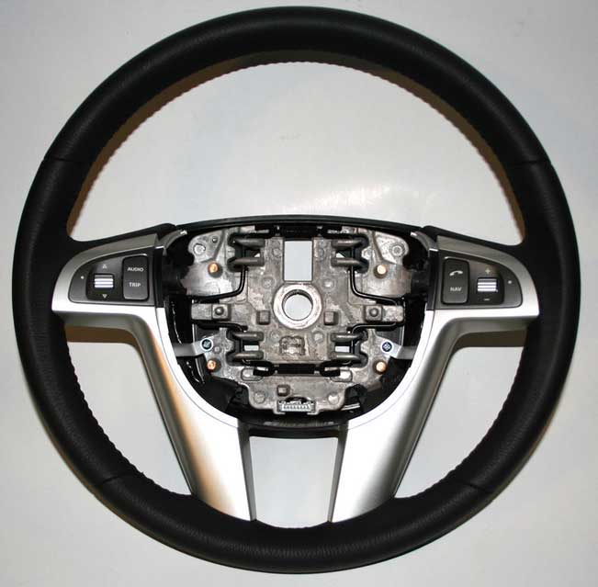

31: Install the Black Wheel Hub onto the rear of the new wheel, ensure the 2 bottom locating tabs are engaged. From the front of the wheel tighten down the 2 hub retaining screws..
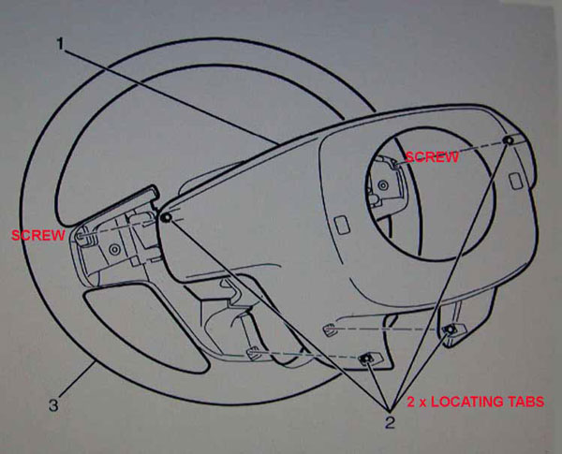

32: Carefully align the MASTER SPLINE inside the steering wheel with the corresponding spline on the Steering Column shaft. Slide the steering wheel onto the shaft.

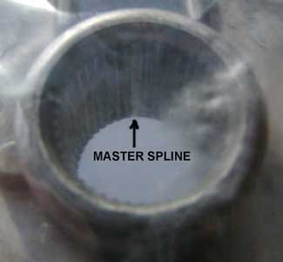

33: Install a NEW steering wheel to steering column shaft retaining bolt (1). ← Recommended by GM.
“Bolts with Micro-encapsulated thread sealant must be discarded after removal”
Steering Wheel Bolt Part No 11610164 Approx $5ea
If you were to re-use your old bolt it would be wise to clean all locking compound off, inspect the bolt
thoroughly and re-apply some Loctite or similar thread locking compound.

34: Tighten the retaining bolt using the Torx T50 socket to 45 Nm (33 lb ft)

35: Connect the Steering Wheel Electrical Connector (2).

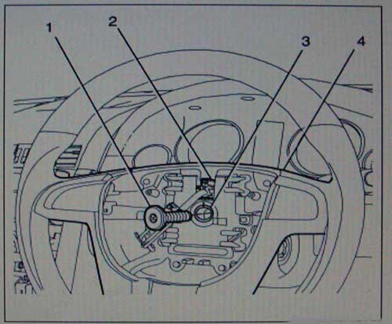

36: Install the Airbag Module to the Steering Wheel (Pic on next page)

- Connect the wiring harness connectors (2) to the corresponding colours on the Airbag Module.

- Connect the black earth connector on the bottom of the Airbag Assembly.

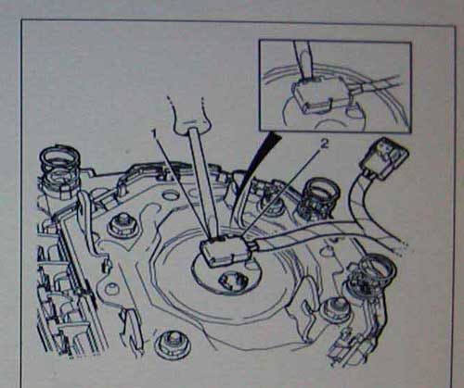

37: Align the Airbag Module firmly into the Steering wheel Assembly applying even pressure to the module until you hear a click.

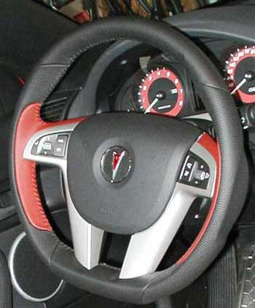

38: Install the Steering Column Trim covers.

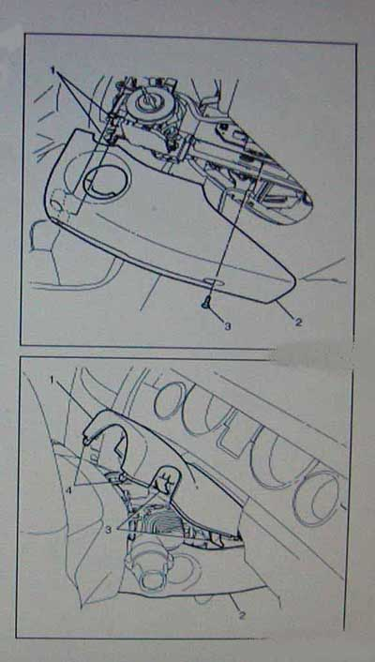

IMPORTANT

28a): Do not use excessive force to mount the steering column lower trim cover (2) to the mounting tabs (1).

28b): Lift the column lower trim cover and press towards the front of the vehicle in order to engage the mounting tabs (1).

28c) Install the Lower Cover and fasten with retaining screw (3).

28d) Tighten the screw to 2 Nm
(18 inch pounds).

28e) Do not use excessive force to mount the steering column upper trim cover (1).

28f): Lower the steering column upper trim cover (1) and press towards the front of the vehicle in order to engage the rear mounting tabs (3).

28g): Press down on the steering column upper trim cover front face in order to clip the front locking tabs (4) to the lower cover.

39: Set the steering wheel and column assembly to the original position and lock the steering column tilt lever.

IMPORTANT : DO NOT PUT A KEY IN THE IGNITION YET.

40: Re-Install the Airbag Fuse in the Instrument Panel Fuse Block.
10 Amp Fuse , Location F1

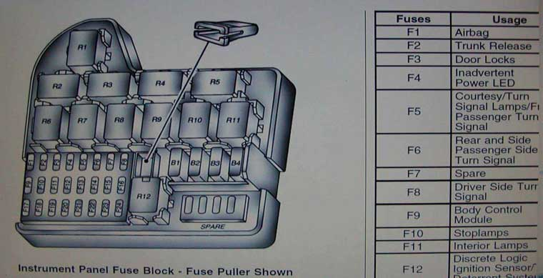

41: Connect the Negative cable to the battery. Tighten the nut to 17 Nm (13 lb/ft)

42: Install the left hand cargo area carpet side.
43: Install the cargo area centre carpet.
44: Close the rear compartment lid.

45: INSERT THE IGNITION KEY & TURN THE IGNITION ON.
The Airbag indicator will flash and then turn off.
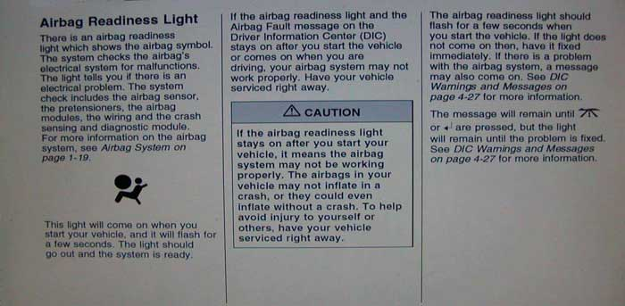
END OF INSTALL INSTRUCTIONS.

